

|  |
| --- |
| **MATHEMATICS DEPARTMENT**  **Year 11 Specialist – 2016**  **Test Number 7: Resource Free**  **Transformation Matrices and Trigonometric Functions** |

**Name: _______________________________________ Teacher: DDA**

**Marks: 41**

**Time Allowed: 45 minutes**

**Weight: 7%  
Instructions:** Show your working where appropriate remembering you must show working for questions worth more than 2 marks.

Part A multiple-choice questions 1 mark each: 3 marks

1 Which of the following does the matrix  represent?

A   A translation 2 to the right and 3 up

B  A dilation by a factor of 2 in the x-direction and 3 in the y-direction

C A translation 2 up and 3 to the left

D   A dilation by a factor of 3 in the x-direction and 2 in the y-direction

E    A reflection in the line y = x.

[1 mark]

2 Which of the following is the matrix for a rotation of  around the origin?

A 

B 

C 

D 

E 

[1 mark]

3 What is the image of the triangle A(2, 4) B(4, 6) C(8, −2) after a rotation of 30° around the origin?

A 

B 

C 

D 

E 

[1 mark]

Part B

7 short answer questions

25 marks

Show your working where appropriate.

4 The amplitude, period and phase shift of the graph y  6 sin are respectively:

Amplitude = 6

Period = 2

Phase Shift = horizontally to the left

[3 marks]

5 The rectangle A(5, −2) B(8, 2) C(0, 8) D(−3, 4) is dilated by the 2 factor in the x-direction and 1.5 in the   
y-direction.

a Find the image of the rectangle under the transformation.

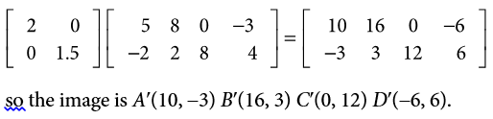

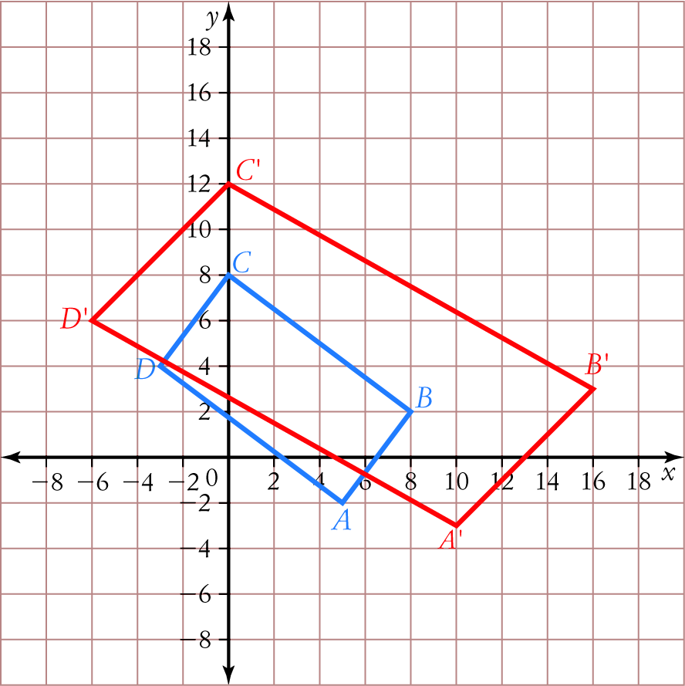

b What is the shape of the image?

Parallelogram

[4,1: 5 marks]

6 a What is the matrix for a reflection across the line y = −0.5x?

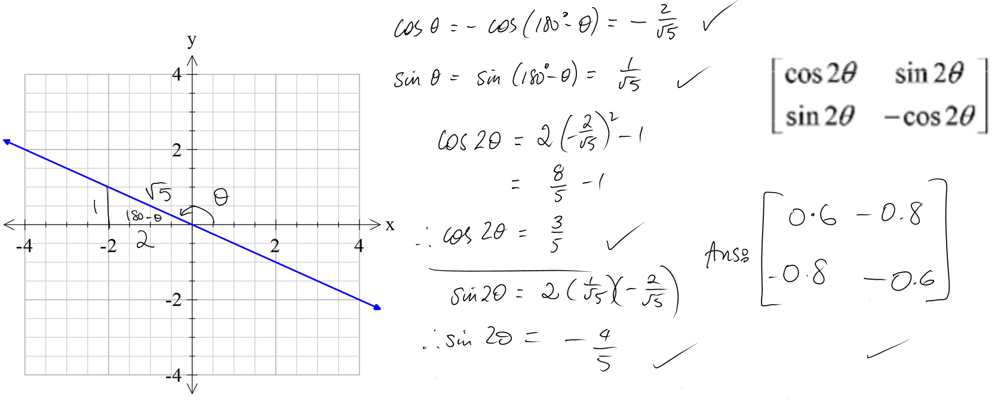 [5 marks]



7 Find the area of the image of the triangle A(−2, 4) B(8, 4) C(1, −1) after the transformation   
T: (x, y) → (3x + 2y, 2x + 5y).

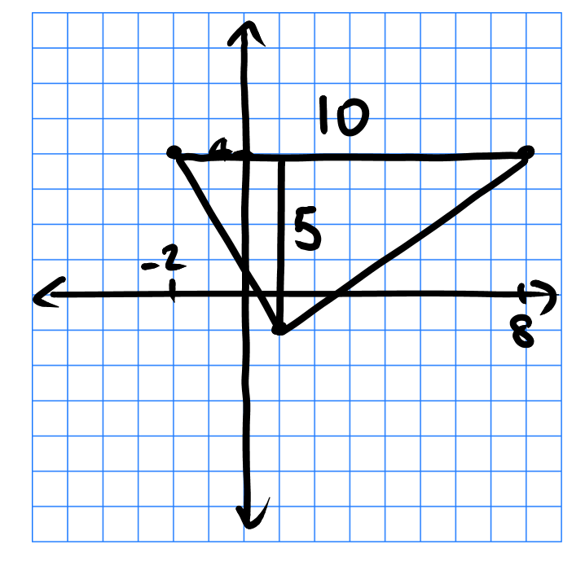 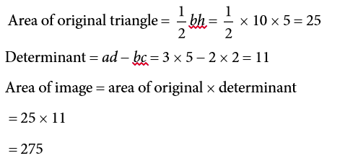



[4 marks]

8 Solve the equation 2 sin   1 for 0 ≤ x ≤ .

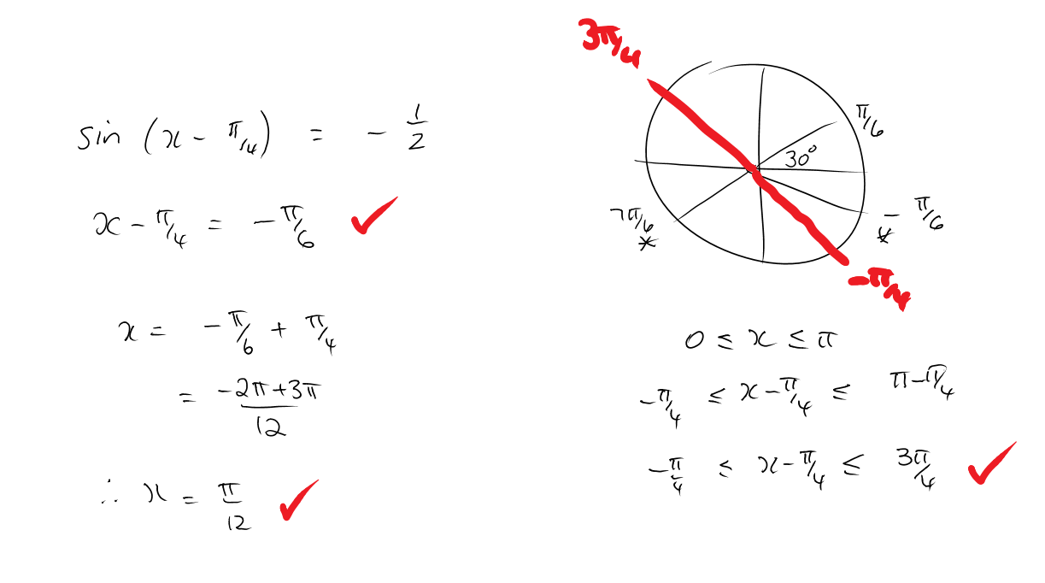



[3 mark]

9 Sketch y  1  2 tan (x) for 0 ≤ x ≤ 2

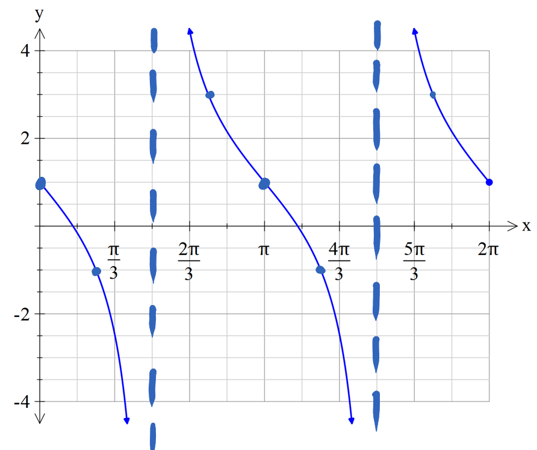

[2 marks]

10 The displacement of a particle is given by x  2 sin (t)  3 cos (t).

a Find the amplitude and period of the motion.







[2 marks]

b Find the greatest distance of the particle from the centre point.



[1 mark]

Part C 3 analysis questions

13 marks

Show your working where appropriate.

11 T1 and T2 are both reflections across lines through the origin.

Use matrices to prove that is a rotation through the angle (2θ − 2φ).

Let the matrix for T1 =  and the matrix for T2 = 

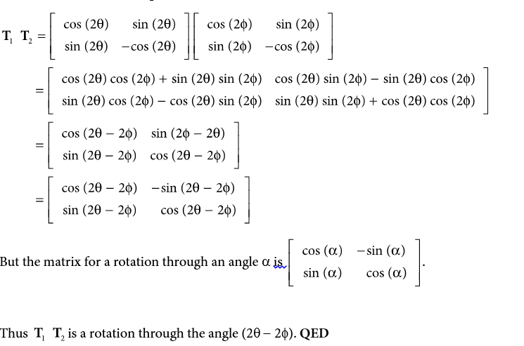



[6 marks]

12 The temperature in a greenhouse is reasonably modelled by the function

T  4 cos, where t is the number of hours since 4.00 a.m. and T is the temperature in °C.

a Calculate the temperature at 8.00 a.m.

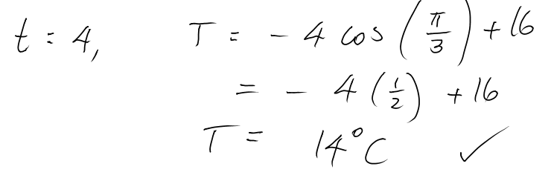

b When does the temperature first reach 20 °C?



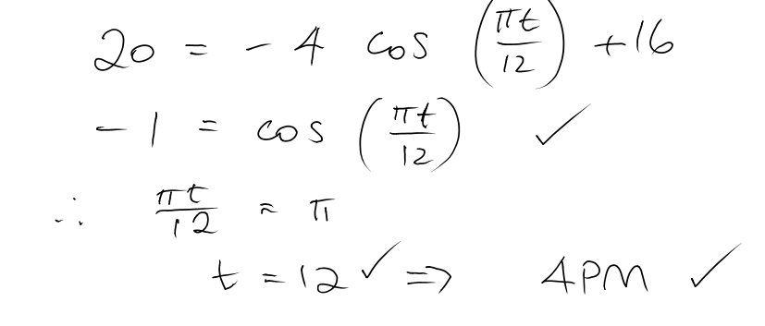



[4 marks]

13 A large hoop is rolling along the ground. The vertical distance above the ground of a point P on the rim of the hoop is given by y  1.25 1.25 cos (2t) where y is in metres and t is in seconds.

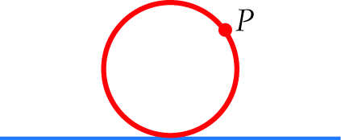

Graphically this looks like:

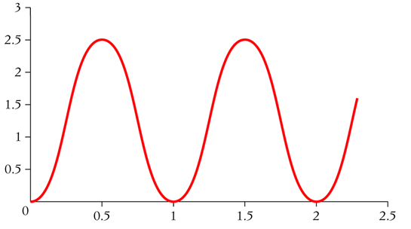

Find the first three times at which P is 2.5 m above the ground.

O.5s, 1.5s, 2.5s

[3 marks]